Asia-China-Jade-Western Zhou-1100-771BCE

This unusual set of fish pendants (ca. 8 cm. long) are carved in semi-translucent, white nephrite jade. Each is pierced through the mouth area for suspension. Jade birds were hung in clusters interspersed with beads on necklaces. This grouping of eight pendants is perhaps unique and exhibits sharp, clear workmanship, grinding and finishing. For instance, the dorsal and caudal fins are clearly incised, the tail fins are uniformly bisected and the eyes are all of the same diameter except on one pendant (number 3 from the top on the left) that appears to have been made by another craftsperson since it also has a more angular head and an expanded tail fin.

Complete groups of Western Zhou jade fish pendants are so rare that only one pair was exhibited in the Museum of Asian Art in Bath, England, (Forsyth and McElney 1994, no. 95).

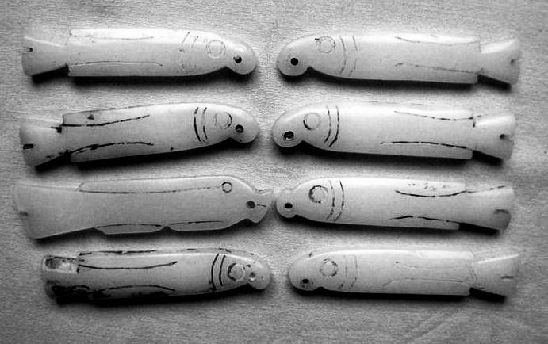

SHAPE \\* MERGEFORMAT 